

Hope

3rd & Elm

Tuesdays

7 am – 11 am

**Home to Some of the World’s Largest Watermelons and**

**Birthplace of President Bill Clinton**

**Farm Fresh Produce Straight from the Back of the Trucks**

**Market Manager: Jodi Coffee**

**jcoffee23@yahoo.com**

**(870) 703-8788**

**Check us out on Facebook at HopeFarmersMarket and on Twitter @HopeFarmMarket**

Nashville

110 South Washington

Fridays

7 am – 11 am

**Open Air Pavilion**

**Kitchen & Restrooms**

**Greenhouse**

**Garden Workshops**

**Kidz Klub and Garden**

**SNAP/DUFB**

**Market Manager: Debra Bolding**

**Dkbolding2352@gmail.com**

**(870) 557-2352**

**Check us out on Facebook at HowardCountyFarmersMarket**

**Websites at**

**nashvillear.com &**

**nashvilleghc**





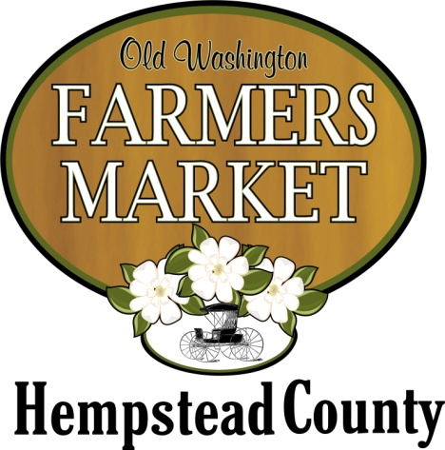

Washington

Behind City Hall

Saturdays

8 am – 1 pm

**Quaint 19th Century Village in Historic Washington,**

**Civil War Capital of Arkansas**

**Cooking Demos**

**Local Arts & Crafts**

**Children’s Garden**

**Market Manager: Sheila Ballard**

**oldwashingtonfarmersmarket@gmail.com**

**(870) 703-4154**

**Check us out on Facebook at OldWashingtonFarmersMarket**

**What you will find at Market**

* **Fresh locally-grown produce sold by the grower**
* **Local honey**
* **Farm-fresh eggs**
* **Fresh-cut flowers**
* **Home-baked goods**
* **Preserves**
* **Hand-made soaps**
* **Hand-crafted items at some markets**
* **Cooking demos and workshops**

**Weekly Drawings!**

While at the markets, be sure to enter the weekly drawings for produce and other market goods!

**Email Notices . . .**

The markets send out weekly email notices of what’s expected – Sign up for the notices while at market.

**WIC FMNP & SNAP**

WIC Farmers’ Market Nutrition Program vouchers are accepted at all three market sites. SNAP/DUFB (double your SNAP dollars) is accepted at Howard County Farmers Market.

**Want to Sell at Market?**

**Registering to sell**

**Who is Eligible –** Those who grow produce or make other farm products (e.g. cottage goods) within 75 miles of Washington, AR, may apply to sell at the markets. Farm products include vegetables, fruit and other produce, honey, eggs, home-baked goods, hand-made soaps, jams and jellies. Some hand-crafted items may be sold, depending on the market.

**Seasonal Vendors –** Vendor fees are $50 per market for the entire season, except for those vendors who sign up during the annual grower meeting held in January. Approved vendors who register during the January meeting may sell at all three markets on any market days for the entire season for a single fee of $75.

**Day Vendors –** Registration for Day Vendors is $15, which includes vouchers for three days at any of the markets (days do not have to be consecutive,) $5 per day thereafter at each market.

**For More Information -** Contact any of the market managers to apply or to find out more about how to sell at market!

Howard and

Hempstead County

Farmers’ Markets

May - September

2018

